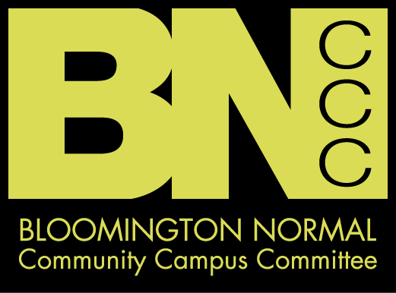

Community Forum
October 14, 2009
Meeting Minutes

1. Welcome and Introductions: Karen Schmidt, BNCCC Member
- She is a member of the Bloomington City Council and the Librarian at Illinois Wesleyan University.
2. BNCCC Background: Bobbie Lewis-Sibley, BNCCC Community Liaison
- In 2005, as a subcommittee of the Heartland coalition, the committee formed to offer server merchant training in our community. It began with 6 members and has grown to over 35.
- In 2006, the committee decided to expand its priorities and named the committee the Bloomington Normal Community Campus Committee (BNCCC).
- In 2007, received a grant from the state to work on reducing high-risk drinking in our campus communities.
- Developed a mission statement: Reduce high-risk drinking and related consequences among students of Bloomington-Normal.
- Developed a vision statement: Our vision is for the Bloomington-Normal community to be a community that is fun, safe and diverse, operating in integrity and supporting families of all kinds.
- After reviewing community wide data, the BNCCC has developed and is working to implement a strategic plan to reduce high-risk drinking and related consequences in our community.
- In 2009, received the Department of Education High Risk Drinking grant.
3. Presentation of Data: Bob Rogers, BNCCC Member
- Data is a starting place, a point of reference and discussion, it is not truth, but rather information to fuel informed dialogue…..
    - Data is limited by what has been collected and the limits of method and data collection approach.
    - This data is heavily influenced by the improved data collection between 2008 and 2009, i.e. differences observed are in large part a function of improved data from year 1 to year 2.
    - Data suggests areas of attention for continued community and campus prevention efforts.

- Data we have collected from the four local campuses:
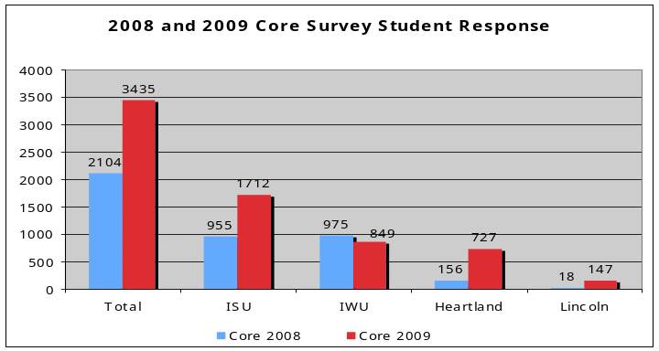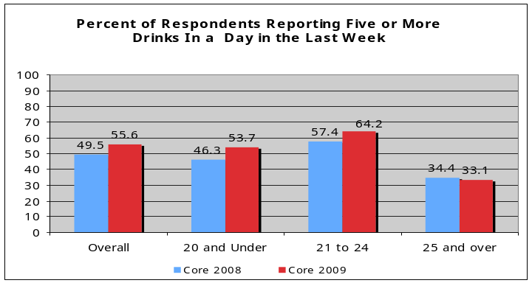
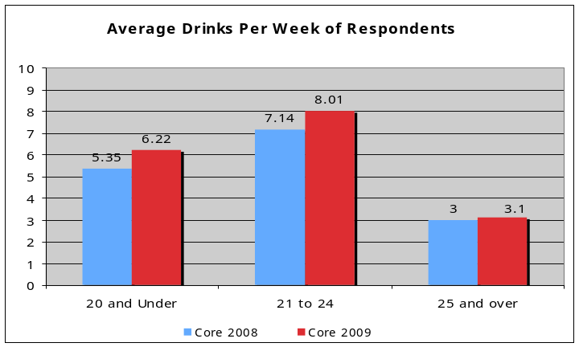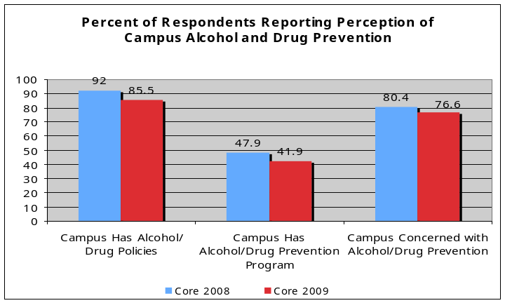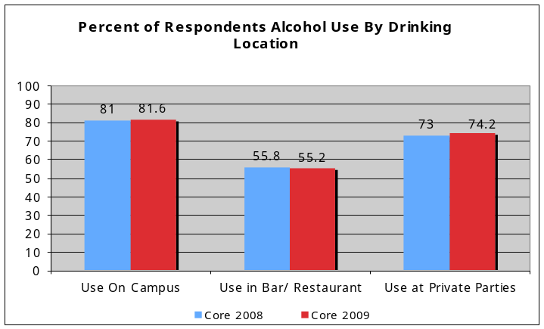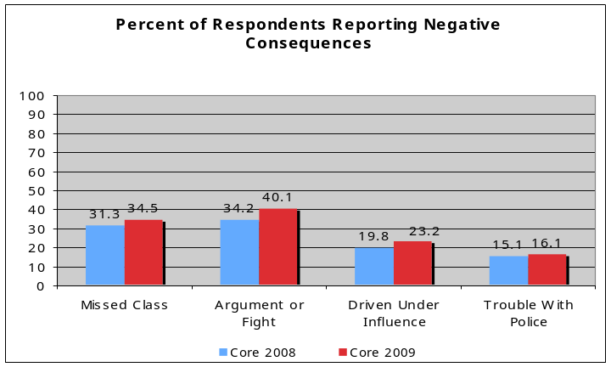

- McLean County Sheriff’s Data:
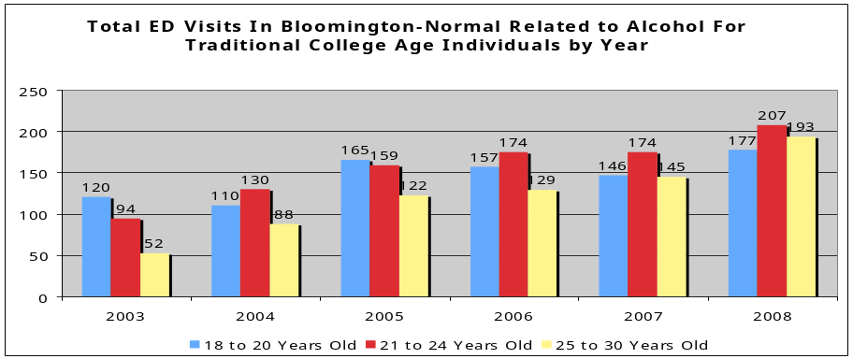

- 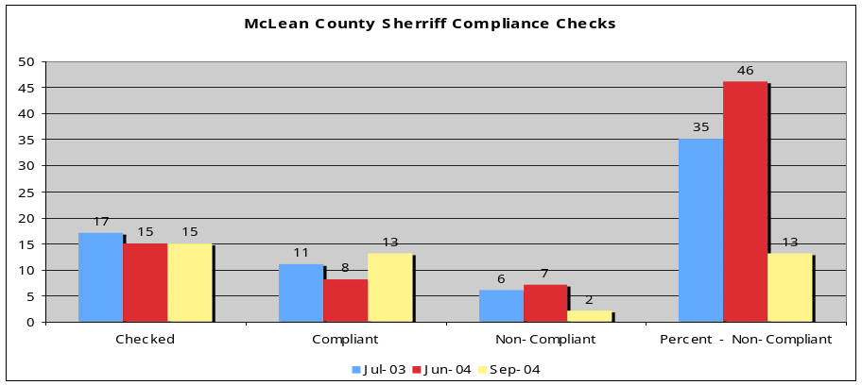Emergency Room Data:

- Looking at the Illinois Youth Survey (IYS), 40% of twelfth graders report having consumed alcohol in the last month.
- In McLean County the average age of first consumption is 16.
- Students come to college with drinking histories. It does not begin in college.
- Many underage students are consuming in heavy amounts.
- We see a spike in 21-24 year olds who consume alcohol in amounts that lead to consequences.
- There are individuals over the age of 25 that consume alcohol in amounts that put them risk.
- Students realize there are alcohol policies in place on the campuses. Here at IWU much of this recognition is due to Associate Dean Greder’s diligence in getting the word out.
- 75% of students report the school is concerned about there alcohol use.
- The prevention efforts need to be better known.
- Students report drinking on campus, in bars and restaurants, and to the greatest extent at private parties.
- 18% of students report they can purchase alcohol without being asked for an ID.
- Within the last month, the Sheriff conducted a compliance check and 5 out of 35 establishments were found to be in violation.

4. Police Perspective: Randy Wikoff, Sergeant Bloomington Police Department
- He has been with the Bloomington Police Department for over 20 years.
- Bloomington Police are working on neighborhood policing and partnering with IWU.
- When drinking related incidences occur ordinarily ordinance violations are handed out. Rarely are criminal charges pressed.
- Bloomington has officers that actively patrol the downtown bars conducting compliance checks.

5. Higher Ed Perspective: Darcy Greder, Associate Dean of Students, IWU
- Been at IWU for 32 years and seen many changes over the years.
- 32 years ago IWU had 1550 students and 67 lived off-campus. Of those that did live off-campus, all were 21 and lived amongst faculty.
- Now 400 students live off-campus and they do not live in neighborhoods where faculty live.
- Realize as an institution we need to provide students with more direction in order for them to be successful off-campus.
- Working to help students understand responsible citizenship.
- We look to the community to partner with us and let us know what our students are doing.
- Bloomington-Normal is a wonderful collective community that supports our students:
- Provide Money
- Send Students
- Provide Internships and Employment

10. Open Discussion:
- Richard Buchanan, Bloomington Liquor Commissioner, inquired what the BNCCC is doing with the additional grant funds that have been received. Bobbie Lewis-Sibley, BNCCC Community Liaison, shared the BNCCC is working on a social marketing campaign to reduce high-risk drinking and additional assessments to better understand our community and provide better guidance for strategy selection.
- Marabeth Clapp, Bloomington Liquor Commissioner, inquired what the landlords could and should be doing to curtail high-risk behaviors. Meredith Lovelass, BNCCC Member and Property Owner, shared that first and foremost they want to ensure the safety of the students. They have approached this by handing out the off-campus packets from ISU that detail how to host a party responsibly and warning signs to look for. Bobbie Lewis-Sibley of the BNCCC stated that the BNCCC is looking at hosting a breakfast to bring the Property Owners together to start building a relationship and work with them on ways to reduce issues at student apartments.
- Karen Schmidt, Bloomington City Council and BNCCC Member, inquired what can be done with over-service in the bars. Bobbie Lewis Sibley, BNCCC Community Liaison, discussed STEPS (Server Training to Encourage Profitable Service) a program designed to teach servers about the liabilities associated with over-service and how to reduce risks by limiting over-service.
- Steven Purcell, Bloomington City Council Member, shared he supported keg registration because he sees a great need to reduce risks at parties where over-service takes place. His district is most of IWU’s Campus and he has received calls in the middle of the night when others are woken up by loud parties and are upset.

11. Closing Comments: Darcy Greder, IWU
- Shared special thanks for the leadership Jeff Fritzen and Kathy Cavins provide. Thank you to all who came to the forum and spent time looking at the issue with us. Thanks to all of our presenters.
- The BNCCC has a website: www.BNCCC.org.
- Our meetings take place the third Thursday of the month and all are welcome to attend.

